Model(s): BRH
Overview
Roof Hatch products provide safe and convenient access to roof areas using interior ladders, alternating tread devises and stairs. Roof hatches are designed and built for years of convenient and weather tight roof access for various applications including; Personnel, Translucent and Equipment.
The following is a general instruction for installing, operating and maintaining roof hatch products. These are recommended general guidelines only. Locally accepted roofing and sealing practices and procedures should be followed to ensure the ultimate weather-ability of roof hatches installed into the various types of roofing systems used.
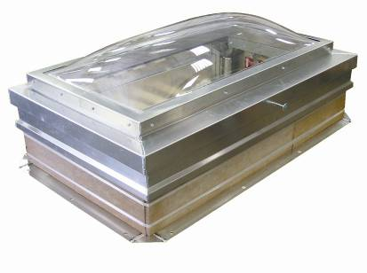
Application Note: Roof hatches, including translucent cover roof hatches are intended for commercial building applications. Condensation may occur as a natural result of humidity levels and temperature variations between indoor and outdoor temperatures, which can become exacerbated in residential type applications. Environments with excessive moist, hot air are more susceptible to condensation, especially during winter months with colder temperatures.
Installation
Roof hatch products may be installed on a flat or sloping roof with up to a 3:12 pitch. When installed on a slope, the hinge side must run parallel with the slope.
- Place the roof hatch over the existing opening in the roof. The roof rough opening dimensions are equal to hatch dimensions as measured from the inside curb to inside curb. For example, a 36 inch by 30 inch fixed ladder access hatch, will have a roof rough opening of 36 inches by 30 inches.
- The roof hatch curb flange comes with two (2) types of mounting holes to accommodate multiple fastening methods practiced and accepted at a local level.
  - Mark the pre-drilled 5/8 inch diameter holes from the mounting flange through to the roof deck or a concrete curb. Drill roof deck or concrete curb for installation of anchors or other fasteners (provided by others). Bolt or otherwise fasten roof hatch curb flange to roof deck using 3/8 inch or 1/2 inch bolts with washers.
  - Mark the pre-drilled 3/16 inch diameter holes from the mounting flange through to the roof deck, typically into a built up wood fame curb. Fasten roof hatch curb flange to faming using roofing nailers and/or screws, recommended size #10.
- Mark the pre-drilled 5/8 inch diameter holes from the mounting flange through to the roof deck or a concrete curb. Drill roof deck or concrete curb for installation of anchors or other fasteners, provided by others. Bolt or otherwise fasten roof hatch curb flange to roof deck using 3/8 inch or 1/2 inch bolts with washers.
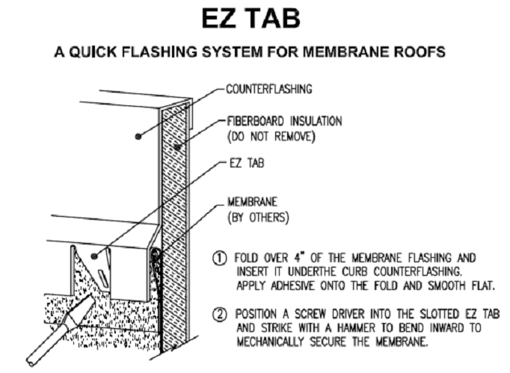
  - Mount cant strips, by others, surrounding the roof curb when applicable. The size is to be determined by a roofing installer, based on the roofing material to be provided.
  - Install roofing material up to and surrounding the roof curb, and under the counterflashing at the top of the curb. Use the EZ tab feature as described below to provide additional mechanical support to hold and secure roofing membrane. Lap and seal all joints in roofing material to provide a weathertight seal.
Operation
Roof hatches are designed and built for years of dependable roof access. To meet the demands of an exterior application, the doors are manufactured from steel or aluminum. The curb and cover are insulated and have a continuous extruded thermal EPDM gasket that creates a weather resistant seal. The standard curb comes with a counterflashing incorporating EZ tabs to assist with mechanically securing roofing material/membrane. The steel roof hatches come standard with a finished baked on powder coat paint that offers the best corrosion protection in the industry.
The basic components for door operation include turn handle latches incorporating padlock hasps, spring hinge assemblies and a locking hold open arm as detailed:
- Latch: Latch with interior rotating handle and exterior, gasketed turn handle, both incorporating padlock hasps to accommodate interior and/or exterior locking options.
- Spring/Hinge: Concealed, tamperproof, heavy-duty zinc plated steel spring/hinge packs integrated with counter balance compression springs to ensure ease of opening and closing during use.
- Hold Open Arm: Locking hold open arm automatically engages and locks when the door fully opens. The hold open arm must be engaged in the locked position to ensure that the door does not close unintentionally. Pull the red vinyl grip handle to unlock and safely close the door.
- Gasket: Weather tight, continuous adhesive backed gasket on curb.
Note: Larger hatches, especially hatches that are over 72 inches in length, may need two people to ensure proper closure.
Maintenance
- Roof hatches should be manually operated once a year to check performance.
- Lubricate moving parts such as hinges and latches with a silicone spray lube as required to maintain a smooth opening and closing of the door. Do not over grease. Do not use regular lubricating oil as it can attract dust and grit.
- Non-moving parts can be cleaned with a mild soap or dishwashing detergent and water solution.
- Gaskets can be cleaned with a clean, damp, lint-free cloth. Do not apply mineral oils, vinyl dressings, or other lubricants to the gasket as they can cause the gasket to break down over time.
- If any questions arise during the operation or maintenance of the products, please feel free to us for call technical support, 1-888-412-3726.
Follow the maintenance instructions to ensure the long life of the product. Contact Babcock-Davis for information on replacing damaged parts.
PARTS LIST
Part Number | Description
RH-KIT-HOA | Hold Open Arm Kit
RH-KIT-HOA-LH | Left Hand Hold Open Arm Kit
RH-KIT-DD-LATCH | Double Door Rotary Turn Handle, Zinc Plated Steel
RH-KIT-SD-LATCH | Single Point Turn Handle, Zinc Plated Steel
RH-KIT-SD-2PTLATCH | 2-Point Turn Handle, Zinc Plated Steel
RH-KIT-SD-CATCH | Single Door Strike Latch with Padlock Hasp
RH-KIT-2PTCATCH | Single Door 2-Point Catch, Zinc Plated Steel
RH-KIT-DD-CATCH | Double Door Latch Strike, Zinc Plated Steel
RH-KIT-SPRINGPACK | Spring Pack, Zinc Plated Steel
RH-KIT-SPRING-YEL | Yellow Compression Spring
RH-KIT-SPRING-GRN | Green Compression Spring
RH-KIT-SPRING-BLU | Blue Compression Spring
RH-KIT-SPRING-RED | Red Compression Spring
RH-KIT-HINGESUPPORT-S | 5-1/4” Hinge Support, Zinc Plated Steel
RH-KIT-HINGESUPPORT-M | 12-1/2” Hinge Support, Zinc Plated Steel
RH-KIT-HINGESUPPORT-L | 18” Hinge Support, Zinc Plated Steel
RH-KIT-LIFTHANDLE | 1” x 6” Lift Handle, Zinc Plated Steel
RH-KIT-GASKET | 10 Feet Gasket

